Making comparisons
Comparative adjectives (Two things)
We use the comparative form of an adjective to compare two things. When we compare three or more things, we use the superlative form of the adjectives.
- White meat is healthier than red meat.
- Travelling by bus is more comfortable than travelling by train.
Less … than
When comparing two things, we can also use the form less + adjective + than (less ≠ more).
- Peter is less considerate than Marta. (= Marta is more considerate)
Not as … as
We can also use the form (not) as + adjective + as.
- Peter isn’t as considerate as Marta. (= Marta is more considerate)
Superlative adjectives (Three or more things)
We use the superlative form of an adjective or adverb to compare three or more things.
- Both John and his brother play football, but John is better.
- John and his two brothers all play football, but John is the best.
The best in
After the superlative, we use in before names of places or before singular words referring to groups of people (class, school, team, family, etc.)
- The Everest is the highest mountain of the world.
- The Everest is the highest mountain in the world.
- She is the best student in the class.
- He’s the tallest in the family.
The least…
We can use “least” as an alternative to “most”
- She is the least considerate person I know.

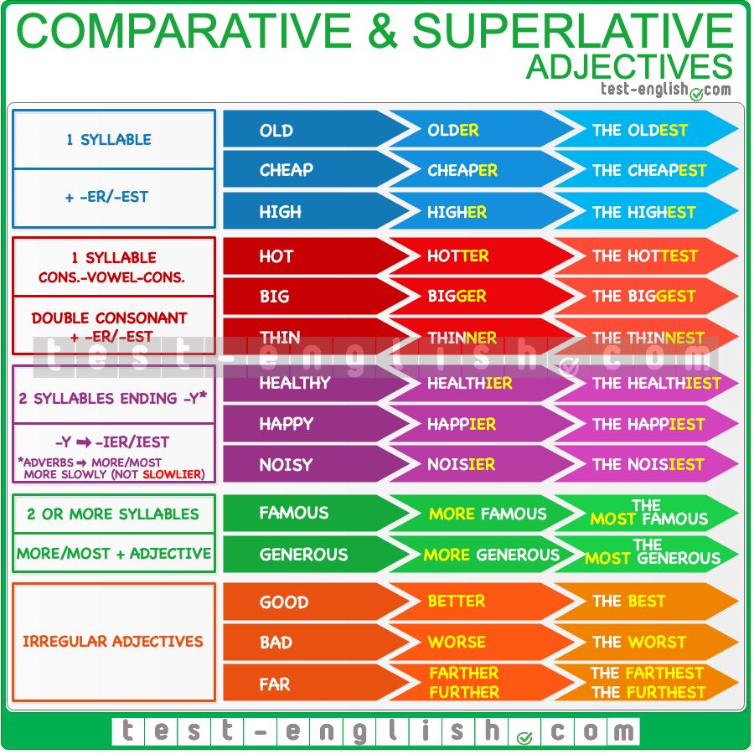

Practise time!
https://test-english.com/grammar-points/a2/comparative-superlative-adjectives-adverbs/

